**Question Paper Pattern and samples**

**UNIT-01**

**1** Compare & contrast between Advanced Mobile Phone Service and Global system for Mobile Communication.

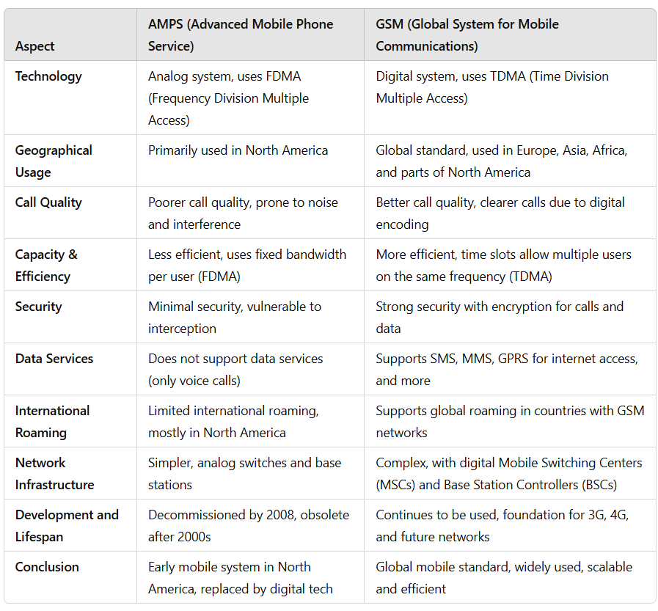

2. Define Personal Communication Service. With a neat diagram explain the basic PCS network architecture.

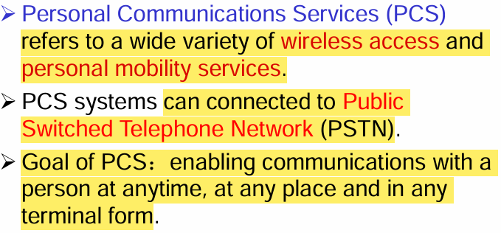

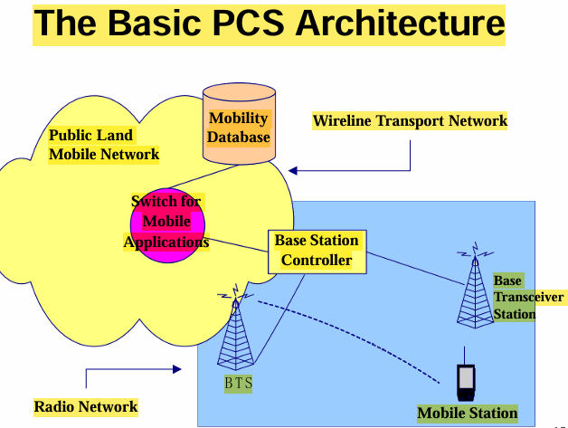

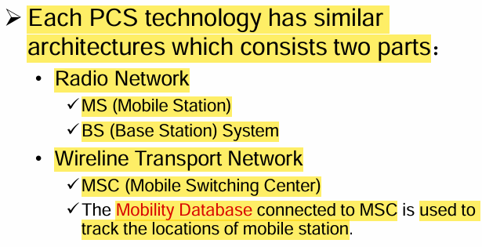

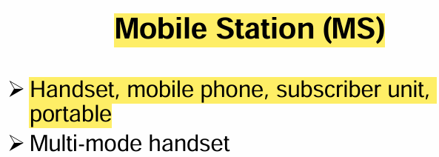

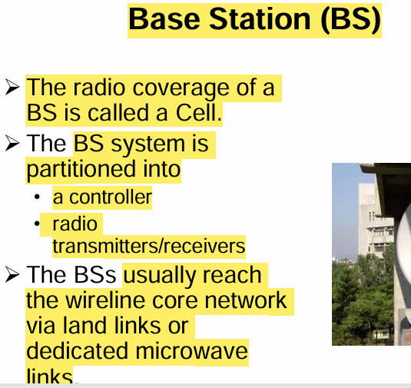

3. Explain Inter-BS Hand-off with a neat diagram and also steps involved in the same.

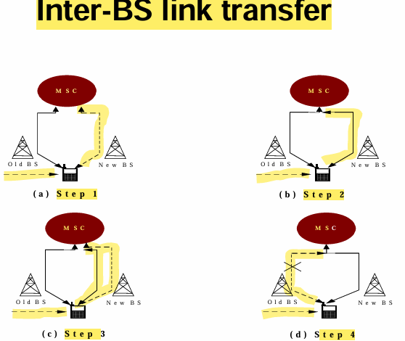

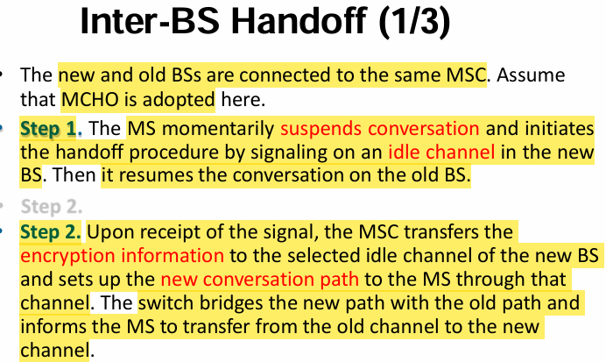

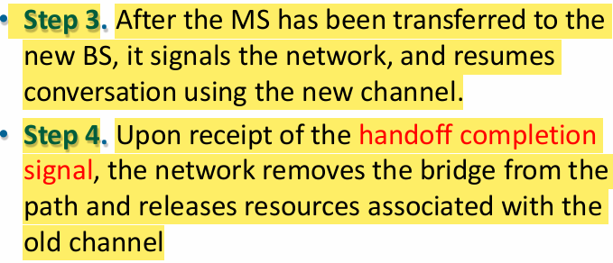

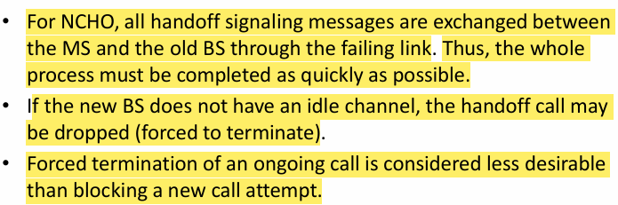

**4.** Define Roaming. Explain MS registration Process with a neat diagram.

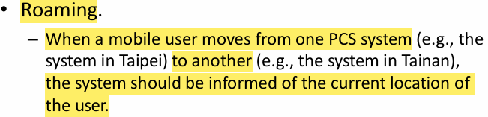

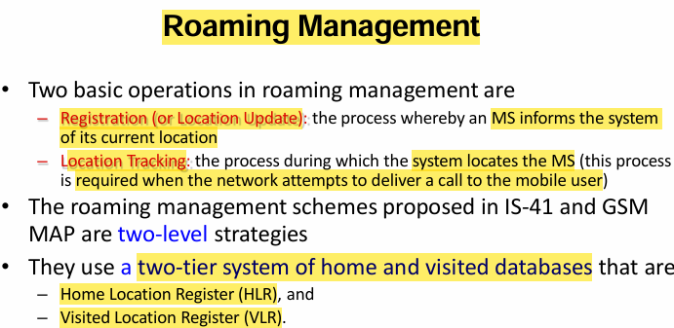

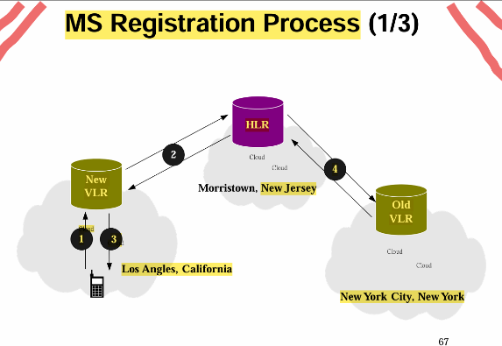

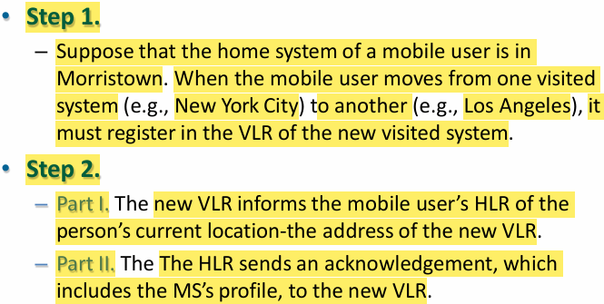

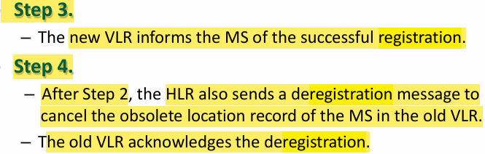

**UNIT-02**

1. Explain GSM architecture with a neat diagram.

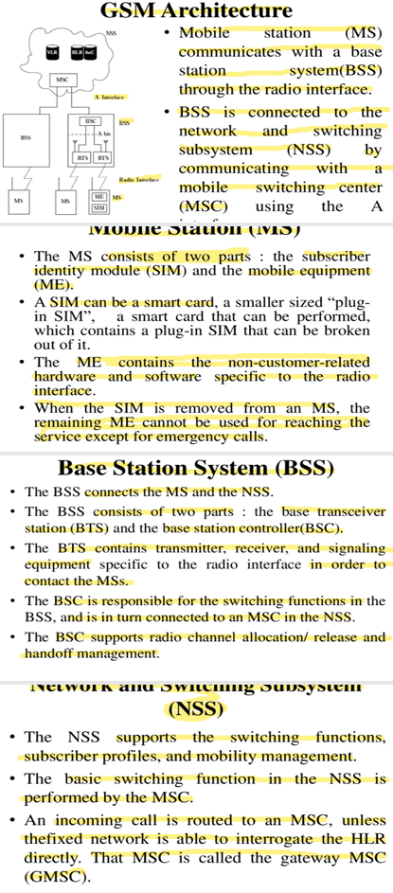

1. Explain GSM Burst Structure with Header format.

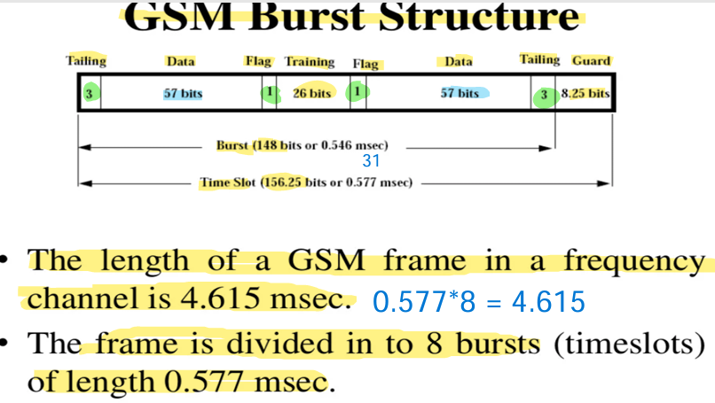

3. Analyze The Following with a neat diagram in context of GSM Basic Location Update Procedure.

a) Inter-MSC Movement

b) Inter-VLR Movement

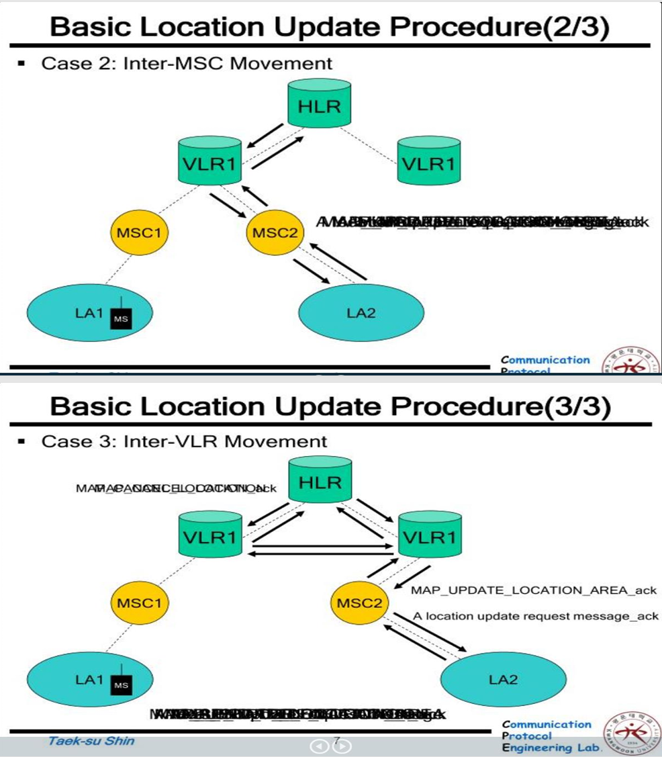

4. Explain with a Neat diagram HLR Restoration Procedure with all steps involved in the same.

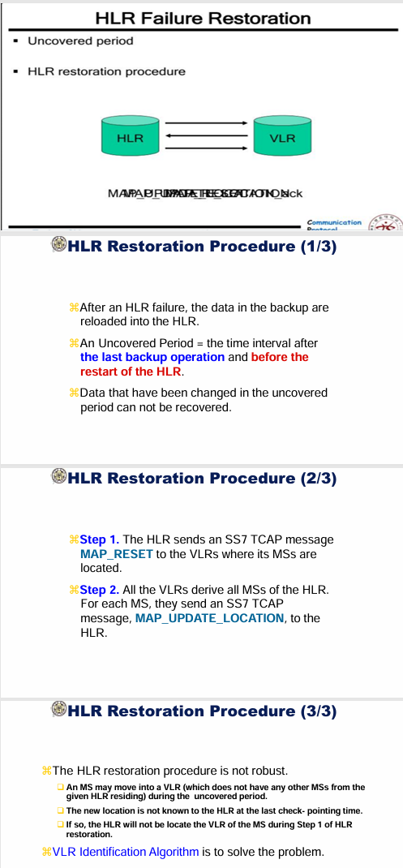

5. Explain the following with respect to GSM

i)MS Registration Process ii)Mobile Call Delivery Procedure

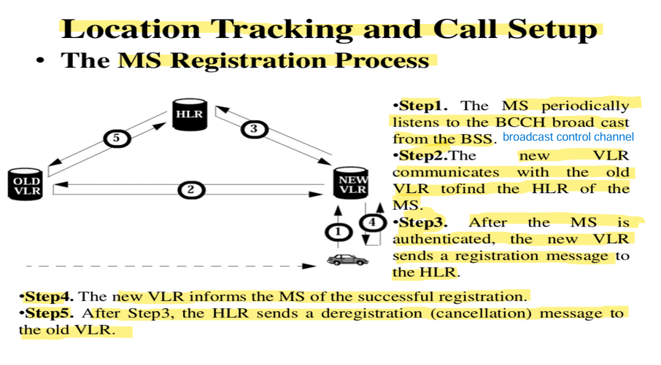

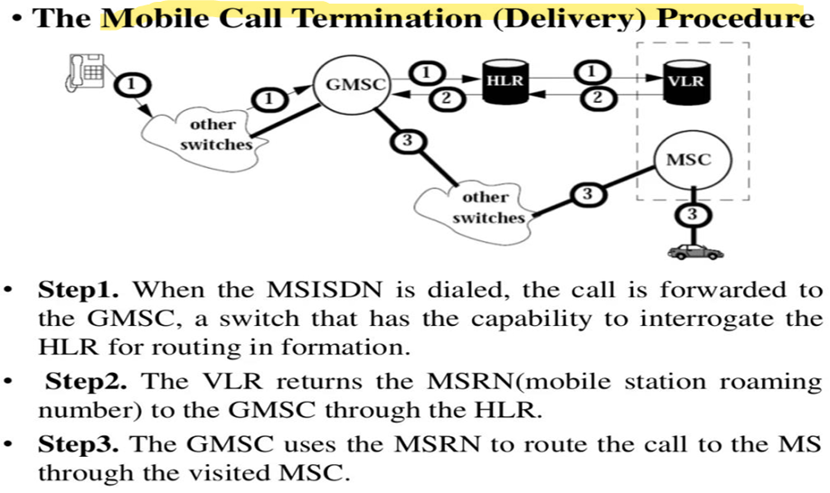

6. List and Explain Basic Requirements of GSM.

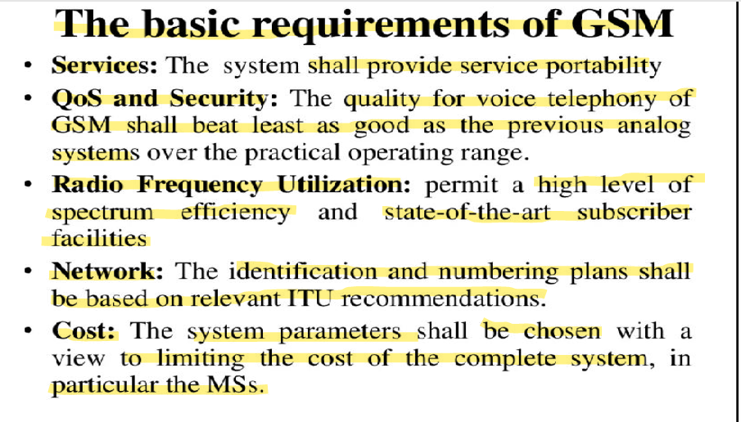

**UNIT-03**

1. Briefly Explain the Architecture of Wireless Application Protocol Model (WAP) with neat diagram.

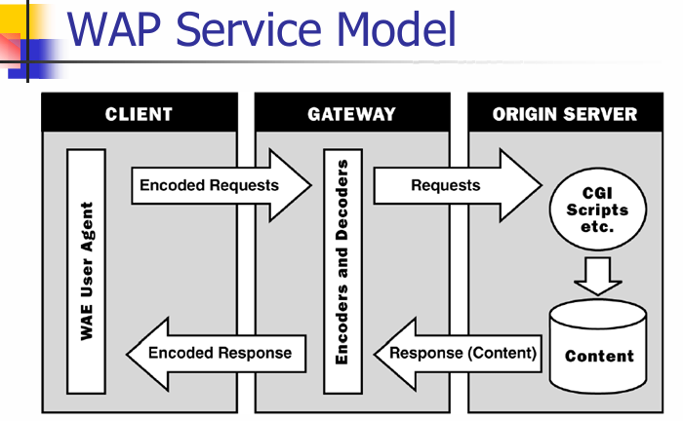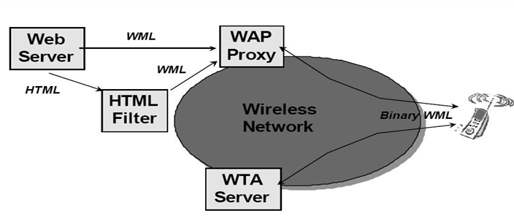

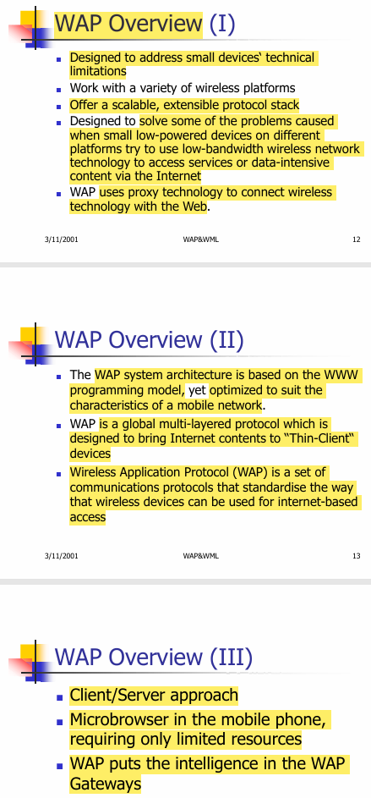

2.Explain the following w.r.t. WAP i)User Agent Profile ii)Caching Model

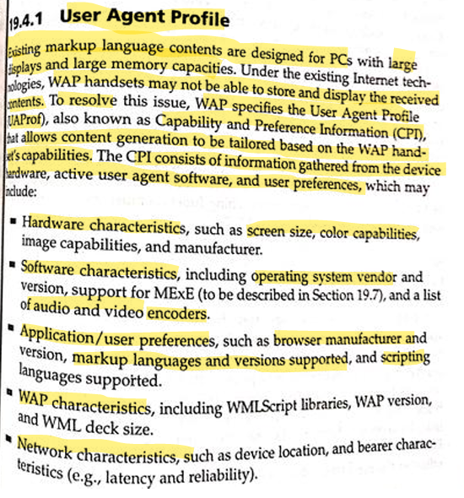

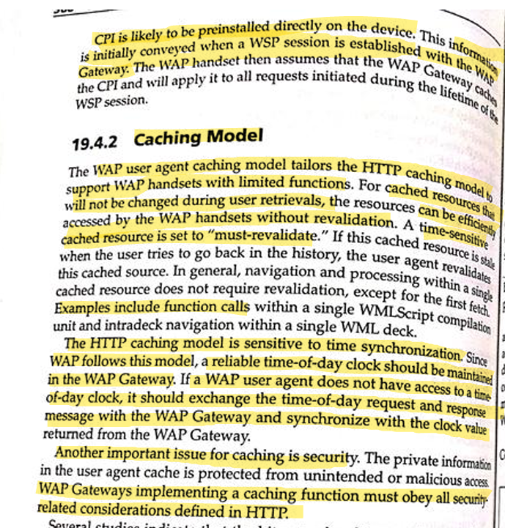

3. Draw a neat diagram for Wireless Application Protocol Model (WAP) protocol stack & Explain the following protocols

i)Wireless Datagram Protocols(WDP) ii)Wireless Transport Layer Security(WTLS)

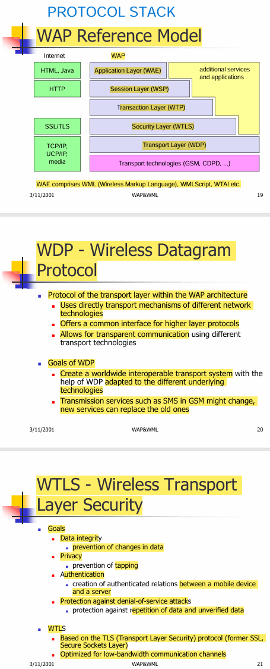

4. Briefly explain the following with a neat diagram related to WAP Developer Toolkits.

i)WAP Simulation Environment ii)WAP Application Trial Environment.

